- aburrido – bored, boring
- amable – kind, friendly
- antipático – mean disagreeable
- barato – cheap
- caro – expensive
- cómico – funny, comical
- débil – weak
- diligente – hardworking, diligent
- divertido – fun
- egoísta – selfish
- fuerte – strong
- generoso – generous
- gordo – fat
- hablador – talkative
- hermoso – beautiful
- importante – important
- lento – slow
- lindo – pretty, cute
- mejor – better
- peor – worse
- responsable – responsible
- rico – rich
- simpático – nice
- tímido – shy
- trabajador – hardworking
- valiente – brave
- alto – tall
- amarillo – yellow
- azul – blue
- bajo – short (height)
- blanco – white
- bonito – pretty
- café – brown
- calvo – bald
- canoso – white haired
- cariñoso – loving, affectionate
- castaño – brown
- corto – short (length)
- chiquito – small, little
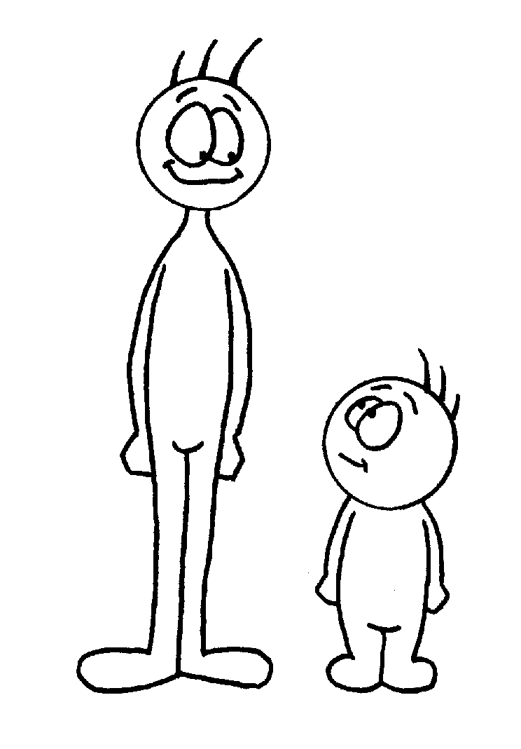
- delgado – thin
- diferente – different
- difícil – difficult
- dorado – gold
- estúpido – stupid
- fácil – easy
- feo – ugly
- flaco – skinny
- grande – big
- gris – grey
- guapo – handsome
- inteligente – smart
- interesante- interesting
- joven – young
- largo – long
- loco – crazy
- mayor – older
- menor – younger
- morado – purple
- moreno – brunette
- negro – black
- nuevo – new
- pardo – brown
- pelirrojo – red haired
- pequeño – small, little
- perezoso – lazy
- plateado – silver
- rojo – red
- rosado – pink
- rubio – blonde
- verde – green
- viejo - old

